HOLY WEEK
&
EASTER LITURGY

2022

Wicklow & Rathnew Parish

ST. PATRICK’S CHURCH, WICKLOW

Saturday 9th April
Confession from 10.30 – 12.00noon

Passion (Palm) Sunday 10th April
Solemn Reading of the Passion 6.00pm (Vigil) / 10.00am / 11.30am

~~~~~

Monday 11th April
Mass at 8.00am & 10.00am

Tuesday 12th April
Mass at 10.00am

Wednesday 13th April
Mass at 8.00am & 10.00am

~~~~~

Holy Thursday 14th April
10.00am Morning Prayer
8.00pm Solemn Mass of the Lord’s Supper
9.00pm-10.00pm Watch and Pray

Good Friday 15th April
10.00am Morning Prayer
12 noon Stations of the Cross
(Dramatised by the Children of the Confirmation Class)
3.00pm Celebration of the Passion
7.30pm Ecumenical Celebration of the Way of the Cross
(Beginning at the Methodist Church)
8.30pm Prayer around the Cross

Holy Saturday 16th April
10.00am Morning Prayer
Confessions: 10.30am - 11.30pm
Blessing of Food 12noon
Easter Vigil 9.00pm
No 6pm Mass

Easter Sunday 17th April
Mass of the Resurrection at 10.00am & 11.30am

~~~~~

From Easter Monday 18th to Friday 22nd April, there will be one Mass in the Parish at 10am in St Patrick’s Church. Please note there will be no evening Mass in Rathnew for this week

All Masses/Services will be available to view online at the time of the Mass/Service.

~~~~~~

ST. JOSEPH’S CHURCH, RATHNEW

Passion (Palm) Sunday 10th April
(Vigil) 7.00pm & 9.00am.

~~~~~

Tuesday 12th April
Mass at 7.00pm.

~~~~~

Good Friday 15th April
Celebration of the Passion at 3.00pm

Holy Saturday 16th April
2.00pm – 3.00pm Confession
No 7.00pm Mass

Easter Sunday 17th April
Mass of the Resurrection at 9.00am

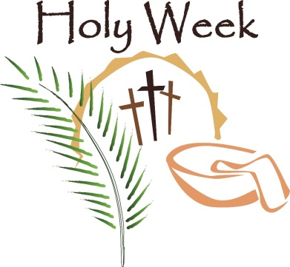

No Penitential Services in the area this year,
however, there are individual Confessions available.

~~~~~~~~~~~~

The Parish Office closes after office hours on
Wednesday 13th April and re-opens on
Monday 25th April at 9.30am

~~~~~~~~~~~~

A very happy & peaceful Easter
to all parishioners and families.

