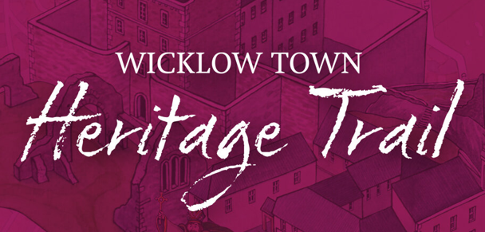
For information on the Wicklow Town Heritage Trail,
visit www.wicklowtown.ie
YOU ARE INVITED TO JOIN OUR GUIDED WALK ON EASTER SATURDAY 16th APRIL
This walk will commence from outside the Dominican Convent at 11am
Locals, Visitors and Tourists are all welcome to join in what is a very informative and entertaining trail through Wicklow’s past telling the rich history of Wicklow Town, from the landing of St. Patrick in 432 to the end of the Civil War in 1923.

On future Saturdays, the weekly guided walk will commence from Fitzwilliam Square at 11am each Saturday.

