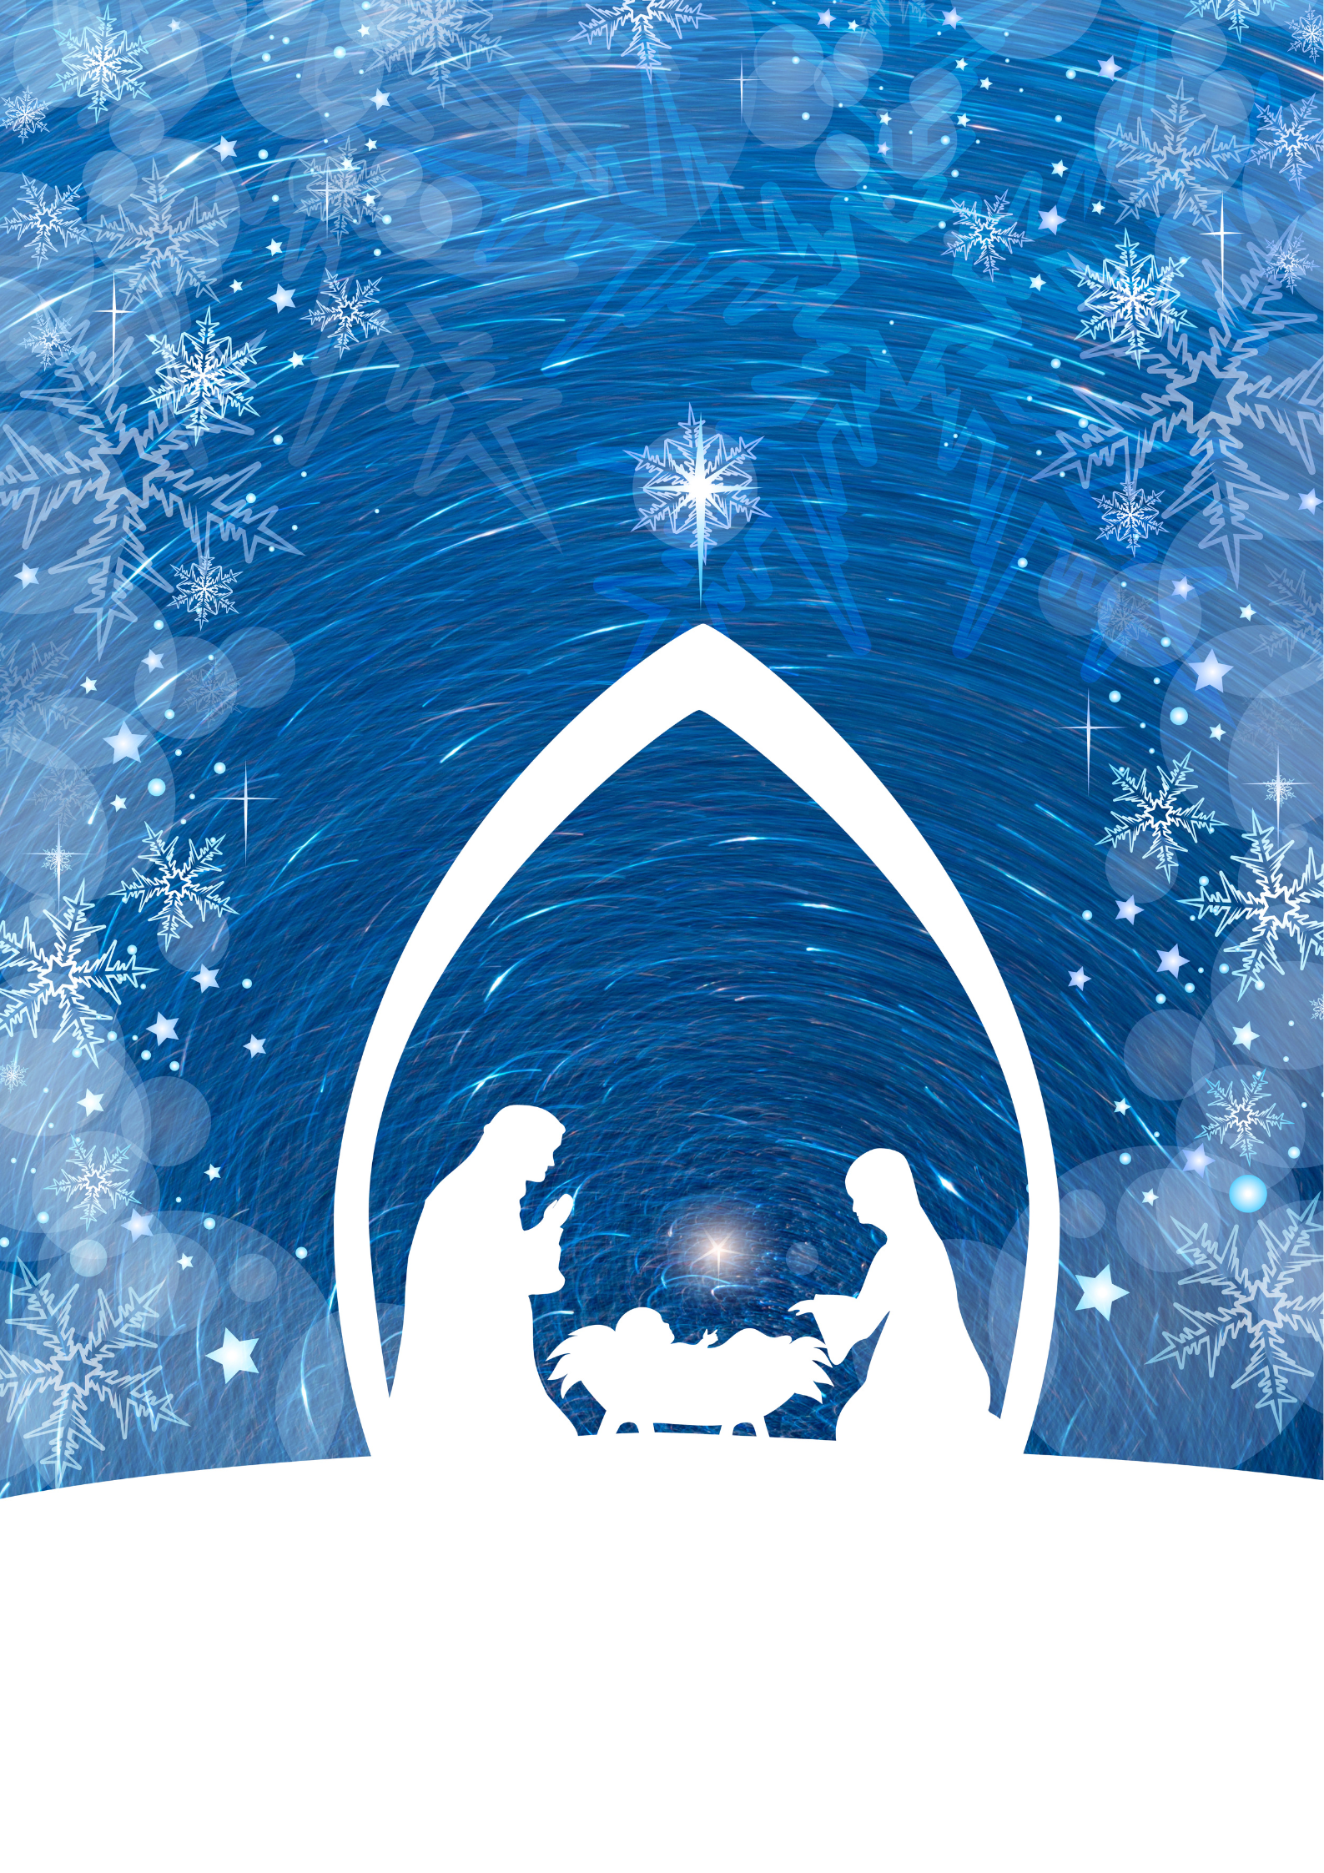
St Mantan’s
Partnership of Parishes
Christmas Arrangements 2025

All Masses / Services in St Patrick’s will be available to view online at www.stmantan.ie

Advent Service
Wednesday 10th December at 7.30pm in Wicklow Church
carols for advent
Sunday 14th December in Kilbride Church at 3pm

~~~~~~~~~~~~~
Christmas Carol Service
Sunday 14th at 4.00pm in Wicklow Church
Everyone is very welcome to this Service.
~~~~~~~~~~~~~
Penance Services all at 7.30pm
Monday 15th ~ Wicklow
Tuesday 16th ~ Rathdrum
Wednesday 17th ~ Arklow

~~~~~~~~~~~~~
CHRISTMAS EVE Wednesday 24th December

5.00pm in Wicklow Family Christmas Liturgy with Holy Communion

Vigil Masses
Holy Hour & ADORATION
Will resume in the New Year
DAILY ROSARY
9:30am Monday to Friday before the 10am Mass

6.00pm ~ Brittas Bay
6.30pm ~ Ashford
7.00pm ~ Wicklow
8.00pm ~ Barndarrig
9.00pm ~ Wicklow
CHRISTMAS DAY: Thursday 25th DECEMBER
9.00am ~ Rathnew & Kilbride
10.30am ~ Wicklow & Glenealy
12noon ~ Wicklow & Ashford
~~~~~~~~~~~~~
ST STEPHENS DAY: Friday 26th DECEMBER
10.00am ~ Wicklow & Ashford
~~~~~~~~~~~~~
Saturday 27th & Sunday 28th
Normal Weekend Masses
~~~~~~~~~~~~~
CONFESSIONS
Confessions will be available by arrangement
or after weekday Masses.

~~~~~~~~~~~~~~
Feast of the Epiphany ~ 6th January 2026
Vigils: Wicklow-6pm, Barndarrig-7.30pm, Glenealy-8pm
No Mass in Rathnew
Day Masses: Wicklow & Ashford – 10am
Evening Mass: Rathnew-7pm

Parish Office
Will close on Friday 19th December 2025 at 12.30pm and will re-open on Wednesday 7th January 2026 at 10.00am

Dear Heavenly Father,
As we come together this Christmas, we thank You for the gift of family and the love that unites us. Thank You for the joy of this season and for the reminder of the greatest gift of all - Your Son, Jesus Christ.
We ask for Your blessing on our family today and in the year to come. May Your love fill our hearts and our home, bringing peace, kindness, and understanding. Help us to reflect the light of Christ in all that we do, to cherish one another, and to grow stronger in faith and love.
We pray for those who are struggling during this season -those who are far from family, those who are grieving, or those facing hardship. May Your comfort surround them, and may Your hope shine brightly in their lives.
Lord, we thank You for the gift of togetherness, for the laughter we share, and the memories we create. May we continue to support and encourage each other, growing closer to You and to one another with every passing day.
In the name of Your Son, Jesus Christ, we pray. Amen.


Every blessing to all of our parishioners for Christmas and the new year

